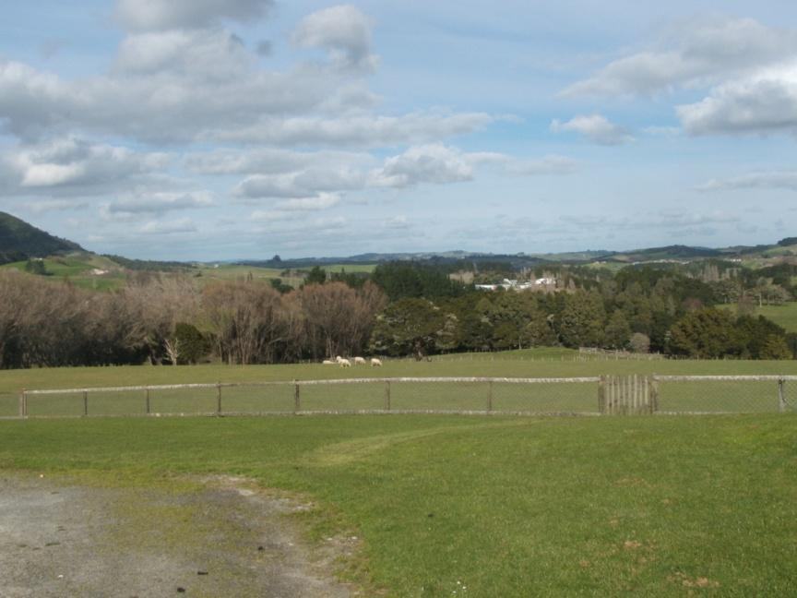

**OTAMATEA CHRISTIAN SCHOOL INTERNATIONAL STUDENT PROSPECTUS**

**GRACE AND TRUTH  WISDOM AND FAITH**

**Tomorrow’s Community Leaders for Life**

**Principal’s Address**

Thank you for your interest in our school. I look forward to welcoming international students from all over the world who are motivated to experience New Zealand education and who will respond to the challenge of hard work along with involvement and participation in academic, sporting and cultural activities.

Otamatea Christian School is a small, Christian, co-educational Year 1-13 school with a warm family atmosphere and an emphasis on character training, values education and high academic standards. Our school has a fine record of providing opportunities for all students who are determined to succeed and who wish to achieve to their full potential. Our senior students strive for A.C.E Academic certificates of Christian Education in Years 11, 12 and 13 which are accepted as entry level into New Zealand Universities and Tertiary Institutes throughout New Zealand.

We aim to assist our students to take full responsibility for their learning and behaviour and we know that quality learning comes from a close partnership between home and school. All students are encouraged to:

• Aim for excellence

• Work towards achieving their God-given potential in all areas

• Have enquiring minds, a sense of discipline, co-operation and responsibility.

• Develop an appreciation of their cultural background, a capacity for leadership, concern and respect for others.

• Demonstrate high standards of honesty, integrity, courtesy, tolerance and loyalty.

• Prepare for future tertiary and vocational opportunities and to acquire the skills and knowledge necessary for their chosen career.

I welcome you to our school and congratulate you on your choice of New Zealand as an educational destination and I hope that the association with Otamatea Christian School will be challenging and rewarding throughout your stay in our country.

Mark Bell  
Principal.

**Overview of Otamatea Christian School**

**Who we are**We are a co-educational Christian school for students from Years 1-13. Our school was founded in 1987 and was the vision conceived of the Maungaturoto Congregational Church. We are committed to meeting academic, physical, spiritual, and social needs of all our students.

We are a private school, operating with a ‘special character’ which supports Christian values and morals. Our purpose is to serve and work with parents who are involved in their children’s education.

The school structure allows the students a smooth transition through their school years. From early learning foundations to outstanding qualifications in academic achievement, the School strives to establish progress for all.

The school is committed to offering students a wide range of school and community based sporting and cultural activities based in the wider Northland Community, as well as maintaining an emphasis on academic achievement. A feature of the school is its safe, secure environment and small classes.

**What we offer**

The School is situated in a rural community overlooking picturesque farmland. We provide individualised learning and small class sizes. Students are provided with the Accelerated Christian Education Curriculum (A.C.E) which is based on the word of God. This international curriculum offers several ACE Certificates available to students in New Zealand, with the High School Advanced Certificate HSAC and the Certificate of Achievement Level 3 endorsed COA (year 12 and 13) Academic Certificates enjoying formal recognition by Universities in New Zealand – Te Pōkai Tara. We accept enrolments at any time throughout the year due to the flexibility and individualisation of our program.

We also offer an afternoon program in which the more creative learning areas of Music, Art, Dance, Drama and Technology are explored for students in years 7 to 10. Students have opportunity to enter work from the afternoon program into National Student Convention every second year.

As our program is tailored and individualised for each student based on diagnostics tests, we will support each student with their learning by providing ESOL as necessary. We do withdraw students individually or in small groups as necessary to support them with their learning.

We will also arrange and provide Homestays.

**What you can expect to see**

* A safe and caring environment where all staff and students work together to serve the students and their families and uphold the spirit of Christ in their everyday practice.
* A friendly, family, atmosphere where all children from the same family can attend the same school from the start of their schooling life until they finish as a year 13 students.
* A faith based mission with workers that are dedicated to the vision of the school.

**Vision Statement**

**GRACE AND TRUTH  WISDOM AND FAITH**

**Tomorrow’s Community Leaders for Life**

**Mission Statement**

**Otamatea Christian School has a threefold mission**

1. To affirm basic Christian values by training up students in the way they should go.
2. To equip students adequately so they can lead others to Christ.
3. To provide an education that fosters spiritual and academic growth as well as releasing the talents of each student for God’s service.

**How we do this:**

* By providing an education that fosters spiritual and academic growth as well as releasing the talents of each student for God’s service.
* By providing support to Christian families in the education and training of their children, in the ways of the Lord.
* By providing an education, that develops responsible, mature and balanced young people with a view of life fashioned and unified by GOD'S WORD.
* By promoting and teaching the lordship of JESUS CHRIST, the fullness of the HOLY SPIRIT and the ultimate authority of GOD'S WORD in all aspects of the school.

**Our Values**



**Our Staff:**

**Mark Bell (BSci; Dip. Adult Tchg; Dip. Primary Tchg)**



**Lynette Bell (B.ED, Cert. Sci., Dip. Primary Teaching, TESOL Certification)**



**Other Staff Members**

**Monitors:** Work as Volunteer Learning Centre Assistants to the teacher.

**Church Pastor:** Paul Chambers

**International Students are provided with**

* A quality education that encourages both academic and spiritual growth

and that is recognised and an acceptable qualification to enter university

in New Zealand.

* Quality homestays
* Personal guidance and support
* A comprehensive orientation program with ongoing support.
* ESOL lessons to assist those students who speak English as a second

language.

* Support and encouragement in reaching your personal and academic goals.

**Our equipment and facilities (4.2.6)**

The ACE system, taught in the morning program, is run in the main building with an open learning space in which both junior and senior classes run alongside each other.

3 rooms are provided for the afternoon program in which the more creative learning areas of Music, Dance, Drama, and Technology are explored. 2 of the learning spaces are equipped with Active Boards, making internet a useful teaching tool in the classroom. The multipurpose room is used for Art, Sewing, Woodwork and Clay-work.

The school is equipped with a generous field for outdoor sports activities and outdoor courts. Students also have access in their learning program to local squash courts. Extra-curricular activities that students can do outside of school hours include Repertory Theatre, Rugby, Squash, Tennis, Table Tennis, Soccer and many other sports. Some of these do require travel. Team sports are available for students staying for a full year. Fees will apply to the associations involved.

In the senior library the study of Rosetta stone language courses and quiet study can take place.

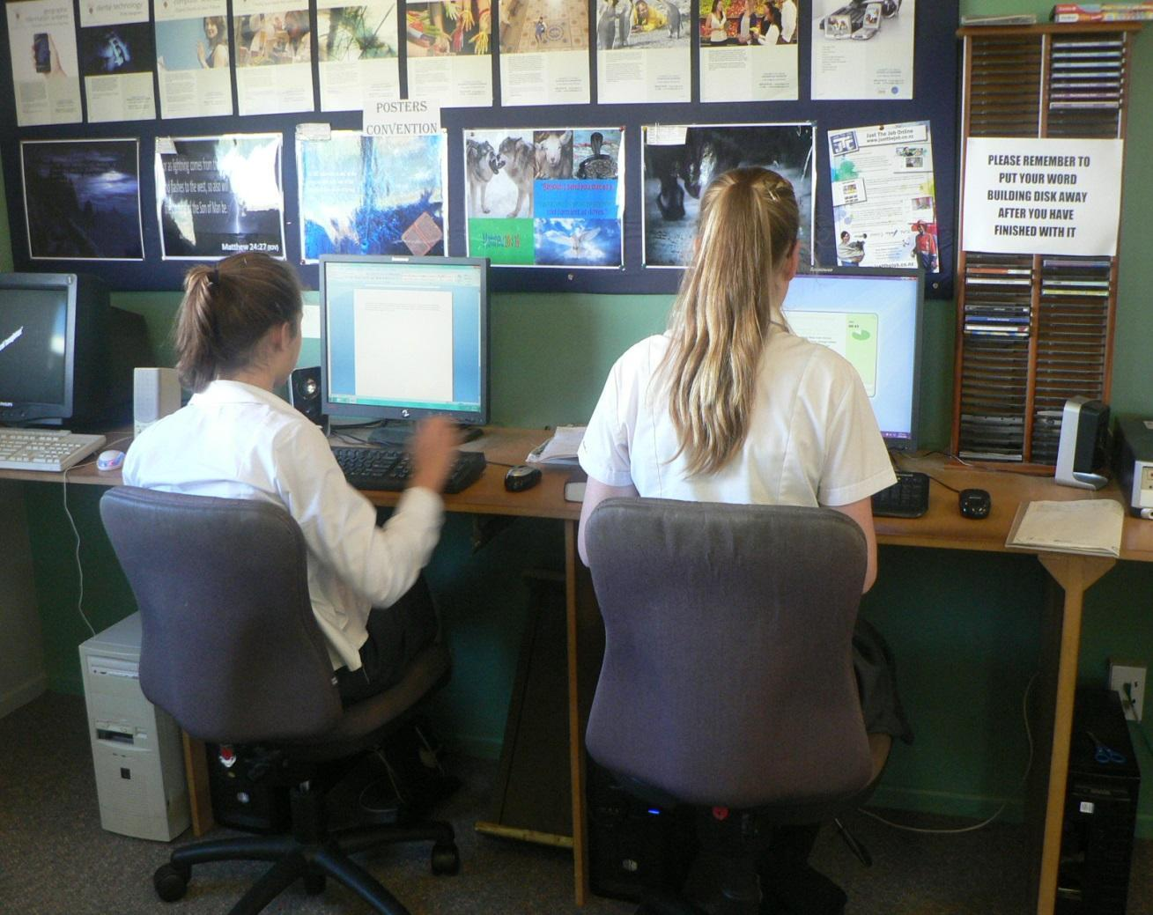

**Courses and Qualifications (4.2.7)**

Our school offers Accelerated Christian Education Academic and Non-Academic Certificates at senior level. The ACE Year HSAC and COA level 3 endorsed Certificates are accepted by universities and tertiary institutes throughout New Zealand as an entry level qualification. NZ ACE Certificate Guidelines available on the FACE NZ Website: [www.**facenz**.org](http://www.facenz.org)or on the school website www.otamateachristian.school.nz

The school teaches well the core subjects Maths, English, Social Studies, Science, Word Building and Literature to all students from Year 7 through to Year 10 in the morning program. All students work on their own individual level of learning in each individual subject in the morning program. In the afternoon program students are taught PE, Health, Technology (Woodwork, Sewing), and the Arts including Visual Art, Drama, Dance and Music. Students prepare for National Student Convention and their curriculum is based around Academics, Photography, Art, Craft, Music, Athletics and Platform events. Horticulture and Topic Studies in Science and Social Studies are also covered. Students work individual and in small groups.

Multi-level courses are also available for senior students across Years 11 to 13. Opportunities are included in the school programme and as extra-curriculum for vocal tuition or guitar tuition (30 mins @$25-30 an hour), and opportunities for education outside the classroom. Allow up to $500 a term to cover costs for extra-curriculum and transport to and from activities and leisure activities. School, inter-school and district sports and cultural events are available as are extension and enrichment opportunities. Students locally may become involved in tennis, squash, soccer, hockey, swimming, quilting, table tennis and rugby. Most activities have annual subs ranging between $50 to $200 per year.

Year 12 and 13 students can apply for a variation to their student visa to allow them to work up to 20 hours per week during holiday periods with written permission from the school and their parents or legal guardian. Please refer to Immigration New Zealand for more information: <https://.govt.nz/new-zealand-visas/options/study>.

**NZ ACE Certificate Guidelines 2022CXPLANATI OF THE**

Accelerated Christian Education is a complete package of individualised curriculum material, covering allgrade levels from Preschool through to Year 13.

Since 1977 the ACE curriculum has been successfully studied by thousands of students in NZ, and today, it is used by many hundreds of thousands of Christian Schools and Home Educators throughout the world.

The ACE curriculum was developed from an international perspective in order that it could be used throughout the world. National units are included in Maths and Social Studies, and at high school level, students are able to choose from over thirty elective courses. (Note that New Zealand ACE Certificates may also include up to 25% non-ACE content, which gives students a huge variety of course options when it comes to crafting the Certificate they need for either the workplace or further studies at tertiary level.)

Each ACE subject is presented in a series of self-instructional workbooks, called PACEs (Packets of Accelerated Christian Education), progressively graduated so that new concepts and truths build upon previously mastered ones – mastery learning. Some courses have optional DVD resources to enhance the learning process.

A student will normally complete twelve PACEs in five or more subjects a year; each group of twelve high school level PACEs being counted as 1 credit towards an ACE certificate. In general, twelve completed PACEs in any particular subject represent one year's work. The standard required to demonstrate mastery is high, with a minimum pass mark of 80% in each PACE test (90% for Word Building) required before a student is permitted to proceed to the next unit of work.

**THE NEW ZEALAND ACE CERTIFICATE**

Accelerated Christian Education offers five secondary school qualifications based on students gaining credits for work completed at various achievement levels using the ACE curriculum materials.

There are several ACE Certificates available to students in NZ, up to (Yr 13) which enjoying formal recognition by Universities New Zealand – Te Pōkai Tara.

**Achievement Certificate:**

**NZ ACE Certificate of Achievement (Any number of credits)**

**Academic Certificates:**

NZ ACE Certificate Of Achievement (Yr 11 to 13 (36 credits)

NZ ACE High School Certificate (Yr 11 to 13) (30 credits)

NZ ACE High School Advanced Certificate (Yr 13) (48 credits)

NZ ACE Certificate with Honours (Yr 13) (48 credits with 5 Level 3 subjects with least a 93% average)

*NB It should be noted that these certificates do not comment on the Christian character of the candidate.*

**NZ ACE Certificate of Achievement (36 Credits)**

The HSAC Academic Certificates or Certificate of Achievement both level 3 endorsed, are necessary for the student who may want to pursue tertiary levels of study and therefore require tertiary entrance qualifications. The Certificate of Achievement is designed to cater for those students who do not meet the strict criteria of the ACE NZ HSAC level 3 Certificates.

We recommend that all students initially work towards the NZ year 10, PACE level 85 before considering an Achievement Certificate.

**NZ High School ACE Certificate Level 2 (Yr 12) (30 credits)**

It is expected that students who have gained this certificate would have the ability to perform at least at the same level as students who have achieved NCEA Level 2.

**NZ High School Advanced Certificate (Yr 13) (48 credits)**

Students with this certificate will have added 6 more credits to their Level 2 Certificate. At least 4 of these credits must be in subjects designated Level 3. Universities New Zealand – Te Pōkai Tara states:

*“This is to certify that the New Zealand Accelerated Christian Education (ACE) High School Advanced Certificate and the Level3 endoresed Certificate of Achievement are accepted by the New Zealand universities for admission ad eundem statum at entrance level. This means that for the purpose of entrance to a university the qualification is deemed to be equivalent to the officially-established common entrance standard in this country.”*

**NZ ACE HSAC and COA Level 3 Endorsed Certificate (Yr 13) can be awarded with Honours**

Students who achieve 10 credits at Level 3, with an average PACE test score of at least 93% in each of those 5 subjects, will be awarded this certificate with Honours. The ACE Academic Council of New Zealand considers this level of performance to be outstanding.

**12)**

**Entry Criteria for Late Starters at Level** 2

International Students with a high level of English competency and Mathematics competency as diagnosed by A.C.E diagnostic tests and/or evidence on level of English proficiency on English Language Proficiency Certificates may start here or on the Late Starters Level 3 program.

Students entering the ACE Program at year 12 and seeking a NZ ACE Certificate must have completed one of the following requirements:

* NZ ACE Level credits; or
* NCEA Level 1: 100 credits [or 80 credits plus 1 ACE credit above 1096]; or
* Cambridge: 5 passes [c+ or better] at O level [or 4 passes plus 1 ACE credit above 1096]; or
* Other recognized academic qualification at the discretion of the Academic Council; or
* If a student is 15 years old [or older] and does not meet the criteria set out above then they must undertake diagnostic testing to ascertain level of mastery. Students who do not meet the standard, i.e. competency at level 8 [PACE 1096], in all areas will first be prescribed appropriate course[s] of study to bring them to this level.
* Proof that entry requirements for any Late Starter course have been met needs to be submitted to the Academic Council before a student is accepted as a Late Starter.

**NZ ACE Certificate – Level 2 (Y 12) – Late StartersLev3 (Yr13)**

**Entry Criteria for Late Starters on the NZ ACE HSAC Year 13:**

Students entering the ACE Program at Year 13 and seeking a NZ ACE HSAC or a COA must have completed one of the following requirements:

* NZ ACE Level 1; or
* NCEA Level 1: 100 credits [or 80 credits plus 1 ACE credit above 1096]; or
* Cambridge: 5 passes [c+ or better) at O level [or 4 passes plus 1 ACE credit above 1096]; or
* Other recognized academic qualification at the discretion of the Academic Council; or
* If a student is 16 years old [or older] and does not meet the criteria set out above then they must undertake diagnostic testing to ascertain level of mastery. Students who do not meet the standard, i.e. competency at level 8 [PACE 1096], in all areas will first be prescribed appropriate course[s] of study to bring them to this level.
* Proof that entry requirements for any Late Starter course have been met needs to be submitted to the Academic Council before a student is accepted as a Late Starter. To gain a Level 3 Certificate a late starter student must complete a minimum of 12 credits [in addition to any previously completed credits] as described in the NZ ACE Certificate Guidelines available on the FACE NZ Website: www.**facenz**.org **A**

**E Certificate – Level 3 (Y13) – Late Starters**

**Notes:**

* Cambridge O and NCEA Level 1 are deemed to be Level 1 ACE
* Cambridge AS and NCEA Level 2 are deemed to be Level 2 ACE
* Cambridge A and NCEA Level 3 are deemed to be Level 3 ACE
* NCEA Achievement Standards and NZQA Unit Standards will be considered for cross-crediting at a ratio of 20 credits to 1 ACE credit, or 10 credits to 0.5 ACE credits

**UNIVERSITY RECOGNITION OF LEVEL 3 [YR 13]**

Although the New Zealand Level 3 Certificate is recognised as a means of entry into all universities in New Zealand, **there is no guarantee that a student with this certificate will automatically gain** **admission**. There are certain degree courses that are selective or that require prerequisites that ACE courses may not fulfil. Other courses are very popular with a high degree of competition for places.

The following suggestions may help increase a student’s chances of acceptance:

* **Gain a high average pass mark [universities place great weight on this]**
* Complete more than four recognised year 13 subjects
* Complete a good number of credits in the academic subjects
* Complete the university enrolment forms as early as possible
* Complete all pre-requisites that a particular course may require

The NZ ACE HSC may also gain entrance to the less popular courses. The chances of a successful application would improve if there were a high number of recognised, Level 2 or Level 3 academic subjects. Given this development and the increased competition for places at university, we strongly recommend that all students intending to apply for a university course of study, work towards the NZ ACE HSAC.

A list of universities and learning institutions and academic pathways past students have taken is available from the school office upon request. All senior students are given information and guidance as to the pathways they can take to achieve future employment as an effective member of society and they are given guidance and information to promote and support their interests.

During the last year of their studies, students on the ACE programme, planning to pursue tertiary studies internationally may choose to sit the American **Scholastic Aptitude Test (SAT)**. These tests have been used to assess the suitability of candidates for tertiary studies since 1926. The SAT gives the student a score by which tertiary institutions worldwide can assess their capacity for tertiary studies. This is not normally required in New Zealand but may be required by some overseas universities. Further information on the SAT may be obtained by visiting the College Board website at: [www.collegeboard.com](http://www.collegeboard.com).

For details of testing in New Zealand see: <http://www.fulbright.org.nz/studyus/tests/sat>.

Every year our students have the opportunity to compete at National Student Convention and develop their talents and interests that are both creative and academic. Students wishing to compete internationally can go to International Student Convention or South Pacific Student Convention. For further information visit the Southern Cross Educational Enterprise website at: [www.scee.edu.au/ssd/conventions/](http://www.scee.edu.au/ssd/conventions/)

Questions and Answers

**What are the criteria for enrolment?**

 International Students enrolling at Otamatea Christian School must:

1.   Have suitable supervised accommodation guaranteed for the entire school year enrolled.

2.   Have parent(s) signed contract stating consent(s) to study at Otamatea Christian School before enrolment.

3.   Prove that they have adequate travel, medical and personal loss insurance throughout their stay in New Zealand.

4.  Inform Otamatea Christian School of any sickness, behavioural, disability or special education needs before enrolment.

5.   Have attained Beginner level of the English language.

6.   Include the latest past school reports and examination results. Including a comprehensive reference from a past school Principal or Head Teacher and one other person.

7.   Meet the conditions of New Zealand Immigration Service student visa/permits requirements.

8.   Accept the direction of the professional staff of Otamatea Christian School subject and level placement.

**What is the International Student’s School Timetable?**

|  |  |  |  |
| --- | --- | --- | --- |
| **Junior and Middle School Years 1 to 10** | | | |
| **MORNING PROGRAM (Individualised Education Program) 8.45-10.15** | | | |
| Devotions | Mathematics  *ESOL support as required | English | Word Building |
| **MORNING BREAK** | | | |
| **MORNING PROGRAM (Individualised Education Program) 10.45-12.15** | | | |
|  | Social Studies  *ESOL support as required | Science | Literature |
| **LUNCH BREAK** | | | |
| **AFTERNOON PROGRAM (Rotational Groups) 1.00-3.00** | | | |
| Sustained Silent Reading | Rotation A | Rotation B | Duties |
| **AFTERNOON PROGRAM** | | | |
|  |  |  |  |
| **AFTERNOON PROGRAM ROTATIONS** | 1. The Arts: Drama, Music, Dance | 1. Technology: Skills based | 1. Health and Physical Education |

|  |  |  |  |
| --- | --- | --- | --- |
| **Senior School Year 11 to 13** | | | |
| **MORNING PROGRAM (Individualised Education Program) 8.45-10.15** | | | |
| Devotions | Mathematics  *ESOL support as required | Mathematics/English | English |
| **MORNING BREAK** | | | |
| **MORNING PROGRAM (Individualised Education Program) 10.45-12.15** | | | |
|  | Christian Studies  *ESOL support as required | Typing/Key Board Skills | Electives |
| **LUNCH BREAK** | | | |
| **AFTERNOON PROGRAM (Individualised Education Program) 1.00-3.00** | | | |
| Electives | Electives | Electives | Duties |
| **AFTERNOON PROGRAM** | | | |
|  |  |  |  |

**Are there school camps?**

The whole school has a camp every second year. Older students attend Regional Student Convention every year. Please see: <http://scee.edu.au/convention> for more information.



**What Accommodation is Available?**

The following accommodation is available:

1. Living with a parent for all students below 10 years of age.
2. Living with a designated Caregiver
3. Living in a homestay (This is recommended for all students).

**Living with a Parent**

The code requires all young international students 10 years and under to live with and continue to live with a parent for the duration of their studies. The designation, ‘Parents’ includes court appointed legal guardians. Documentation needs to be provided to substantiate that a person is a legal guardian.

Living accommodation may be by private arrangement. Private arrangements will be monitored to ensure that all international students are living with and continue to live with a parent during their stay.

It is recommended long term stays arrange private rentals through local Maungaturoto Real Estate Agents. Rental accommodation costs for an average house sits around $500 NZ a week. Accommodation is in high demand in the area so arrangements need to be made as early as possible. For more information, please look up local land agents.

**Living with a Designated Caregiver**

An indemnity document for students living with a designated caregiver will need to be signed. This can be downloaded from the school website. Accommodation and Living Costs will need to be directly organised between the designated caregiver and the parents of the students.

**The Homestay Coordinator will:**

• Visit the home of the designated caregiver prior to enrolment to determine that the living conditions are of an acceptable standard.

• Assess whether the designated caregiver will provide a safe physical and emotional environment for the student.

• Determine that the accommodation is not a boarding establishment

• Meet with the designated caregiver/s and establish communication with the caregiver..

• Meet the student at least quarterly to ensure the accommodation is suitable.

• May require a Police vet to be undertaken, if the education provider considers it appropriate.

• Arrangements to pay board to a designated caregiver will be by private arrangement and will not involve the school.

**Homestay**

Many families value the richness that an international student brings to the family and are prepared to warmly welcome students in as a family member. During a homestay students will get to experience real ‘Kiwi” life in New Zealand. Homestay may also be able to be arranged for a parent/caregiver and a student. Homestay costs include a homestay placement fee of 172.50 and $250 a week for board. For information please click the link, ‘Homestay’ on our website.

**How to apply:**

Link in to our school website <https://otamateachristianschool.com> , go to International Students tab, lick into ‘Application to Enrol’, and the ‘Homestay Application’ form is part of the ‘Application to Enrol’ form. Fill in the part of the form if a Homestay is required. c

Also remember to fill out the medical questionnaire.

Upon receiving your application to enrol and your request for a homestay your homestay family will be interviewed and facilities will be assessed for suitability. You can expect to hear within 4 weeks of application via email.

**Homestay New Zealand**

To get the most out of experiencing New Zealand life, Otamatea Christian School recommends homestay accommodation. International students under the age of 18 are required to live with an OCS homestay family, a parent or a designated caregiver.

Our students experience life as part of a Kiwi family and learn English in a caring environment, and have a home away from home. Our host families are excited to welcome someone new into their lives.

Otamatea Christian School aims to match you with a suitable family one in which you will feel loved and welcomed. Our school is about building relationships between home stay hosts and their guests. Our school likes to promote the idea of cultural exchange through home stay.

Accommodation arrangements for students under 18 years of age must meet Otamatea Christian Schools Board of Governors approval.

Each homestay family is visited, interviewed and the home inspected before any student placement is made. Homestays must sign a contract that details specific rules and standards. In addition, Otamatea Christian School homestay providers must undergo a vetting procedure by the New Zealand Police. Our school provides training and ongoing support for its approved homestays.

All students placed in a homestay and their host families are visited by the Home stay Coordinator to ensure that everyone is happy with the arrangement.

A fee is charged for placement in a homestay as well as a fee to cover board, food and other related expenses. All payments are made directly to the homestay provider from the OCS International student account. Please refer to the ‘International Student Fees Schedule.’



**The benefits of homestay are:**

* A homestay offers a clean, safe and welcoming environment for students to come home to each day.
* A homestay provides a room with a bed, desk for study and adequate lighting and heating.
* A homestay provides guidance and support to students outside of school time.
* A homestay provides opportunity for English practice.  This is an excellent way to increase speaking and listening skills.
* A homestay includes laundry, electricity, heating, water and local phone calls.
* A homestay includes all meals.

Application for homestay is made on the student enrolment application form that can be downloaded from the school website: <https://otamateachristianschool.com>

**INFORMATION YOU NEED TO KNOW**

**Code of Practice (5.3)**

Otamatea Christian School has agreed to observe and be bound by the Code of Practice for the Pastoral Care of International Students. Copies of the Code are available from the NZQA website at [www.nzqa.govt.nz](http://www.nzqa.govt.nz).

**Immigration**

Full details of immigration requirements, advice on rights to employment in New Zealand while studying, and reporting requirements are available from Immigration New Zealand, and can be viewed on their website at [www.immigration.govt.nz](http://www.immigration.govt.nz).

**Eligibility for health services**

Most international students are not entitled to publicly funded health services while in New Zealand. If you receive medical treatment during your visit, you may be liable for the full costs of that treatment. Full details on entitlements to publicly funded health services are available through the Ministry of Health, and can be viewed on their website at www.moh.govt.nz.

**Accident insurance**

The Accident Compensation Corporation provides accident insurance for all New Zealand citizens, residents, and temporary visitors to New Zealand, but you may still be liable for all other medical and related costs. Further information can be viewed on the ACC website at www.acc.co.nz.

**Medical and Travel Insurance (4.2.8)**

International students (including group students) must have appropriate and current medical and travel insurance while in New Zealand. Eligibility for publicly funded health and disability services for foreign/international students is not determined by their domestic or foreign fee-paying status. It is provided by the Eligibility Direction under section 32 of the New Zealand Public Health and Disability Act 2000 ([www.moh.govt.nz/eligibility](http://www.moh.govt.nz/eligibility)).

The direction describes the groups of people who are eligible. Eligibility means the right to be considered for these services and not a right to receive those services. Each person must meet the eligibility criteria in their own right. The eligibility of a person’s child, for example, does not automatically give the parent the same eligibility. ‘Guide to Eligibility Criteria for Publicly Funded Health and Disability Services’ provides information on eligibility for publicly funded (free or subsidised) health care in New Zealand. The Guide is available on the Ministry of Health website at [www.moh.govt.nz/moh.nsf/indexmh/eligibility-guidehome](http://www.moh.govt.nz/moh.nsf/indexmh/eligibility-guidehome), and allows a student or provider to answer yes or no to a series of questions until a page is reached that best describes that student’s situation. It then provides information on whether the student is eligible for publicly funded health and disability services, the eligibility criteria and what the student will need to prove their eligibility.

**What the School requires for Medical and Health Insurance**

International students (including group students) must have appropriate and current medical and travel insurance while in New Zealand.

**You cannot start at our school without insurance.**The school will purchase insurance through a New Zealand insurer who meets the suggested requirements set out in the code. This cover is purchased at the same time international student fees are paid and must be in place BEFORE you leave home.

**Criteria for Enrolment**

**International Students enrolling at Otamatea Christian School must:**

1. Be 11 years of age or older.
2. Have English as your first language or be able to show evidence of a basic level of language proficiency in English as outlined below.
3. Two references that give witness to character and academic ability.
4. Have a desire to learn in a Christian School in the country side of New Zealand.
5. To have tuition fees in advance as per the International Student Fees Schedule.

**Conditions of Acceptance and Language Proficiency Requirement (4.2.3 & 4.2.5)**

**Prospective students will be required to show some English Language Proficiency**

This can be in the form of a Certificate, and be able to understand basic instructions given in English. Have you passed TOEFL, IELTS or any International Tests in English Language? Please include copies in your application.

For students entering the A.C.E system at lower levels students will undergo A.C.E diagnostic testing to ascertain their level of learning and be engaged in conversational English to determine which E.S.O.L pathway will be used. All students will be placed on their diagnosed level of learning in each subject area.

All students will be given a written report of their diagnostics and any learning gaps found. An Individual Education Plan will need to be formulated and given to each student. Parents will also be contacted and given a copy of their Child’s Individual Education Plan.

In some cases, where possible, a SKYPE interview with the Director of International studies will be carried out. You may be required to complete ACE diagnostic testing on line to ascertain your level of English language learning prior to coming to New Zealand. In some cases more than one of these things may be asked for. The ACE system requires a basic understanding of the English language and an ability to read some text at the senior school level. Students who have no English skills at the lower levels will be taught and intensive phonics program.

Students wishing to enter the A.C.E system to gain an A.C.E Academic Certificate will be tested and diagnosed as to their level of English language using A.C.E diagnostic testing to see if they are at a level at which they can achieve this level of learning. If they have sat an English Language Proficiency Certificate and can produce this they will be given an oral and written test to ascertain their level of literacy and understanding. They will still be required to undergo diagnostic testing so that any learning gaps can be addressed. Please read over ACE course requirements for course pre-requisite requirements.

**Otamatea Christian School International Fees Schedule (4.2.1)**

**Tuition Fees Guide* - 1st January 2025 December 2025**

|  |  |
| --- | --- |
| **FULL SCHOOL YEAR (Four school terms)** | |
| APPLICATION FEE:  1st year per application  Ensuing years per application | $500  **OR**  ($250) |
| TUITION FEE:  Includes books and other education resources as well as E.S.O.L tutoring, diagnostic testing and any other related student services. | $15,500 per student |
| ADMINISTRATION FEE:  Includes: International office administration, pastoral care, photographs, activity fees, ID photos. | $600 |
| NZ GOVERNMENT LEVY | $60 |
| **TOTAL COST** | $16,160 per year + application fee |
| **ONE TERM PLACEMENTS (Up to three terms)**  **For those students living in New Zealand without a parent.** | |
| APPLICATION FEE:  1st year per application | $500 |
| TUITION FEE: (per term)  Includes books and other education resources as well as E.S.O.L tutoring, diagnostic testing and any other related student services. | $3,875 per student |
| ADMINISTRATION FEE:(per term)  Includes: International office administration, pastoral care, photographs, activity fees, id photos | $150 |
| NZ GOVERNMENT LEVY | Absorbed into application fee |
| **TOTAL COST** | $4,025 per term + application fee |
| **SHORT TERM PLACEMENTS (Less than one term)**  **For those students living in New Zealand without a parent.** | |
| APPLICATION FEE:  One-off fee paid by students enrolling for the first time. (Non-refundable). | 500.00 |
| TUITION FEES  This is inclusive of tuition, administration, student services, resource fee and government levy. | $387.50 per week |
| GOVERNMENT LEVY | Absorbed into Application Fee |
| ADMINISTRATION FEE:(per week)  Includes: International office administration, pastoral care, photographs, activity fees. | $15 per week |
| **TOTAL COST** | $402.50 per week + Application Fees |

|  |  |
| --- | --- |
| **HOME STAY FEES** | |
| HOMESTAY FEES  For those students living in New Zealand without a parent.  PER WEEK  FOR 46 WEEKS  Administration | NZ $300  NZ $13,800  NZ $50 |

**What’s not included**

|  |  |
| --- | --- |
| **Uniform (unless short term stay)** | $300 |
| **Paces (Work Booklets )**  **Other Stationery** | $800  Allow up to $100 |
| **Extra-curricular activities (sports/music)** | Allow up to $500 per term |
| **Class trips** | Approx. $35 per term ( if Honour Roll gained ) |
| **Student visa** | Approx. $220 per year |
| **Student insurance (compulsory)** | Approx. $400 per year |
| **School camps/Convention** | Allow $400 per year |
| **ACE Certificate Fees (Y11/12/13)** | Allow $90 per certificate |
| **Transport to school** | Allow $250 |
| **Airport transfer** | $200 each way |
| **Pocket money** | Maximum of $50 per week recommended |

**BANK ACCOUNT DETAILS**

|  |  |
| --- | --- |
| **Bank:** | ANZ Bank |
| **Branch:** | Whangarei |
| **Branch Address:** | Bank Street, Whangarei |
| **Account Number:**  **Account Name** | 060365001337303  International Account |
| **Beneficiary:** | OTAMATEA CHRISTIAN SCHOOL |
| **Beneficiaries Address:** | 98 Hurndall Street, Maungaturoto, 0520 |
| **Reference:** | Student’s Surname then first name |

***PLEASE NOTE: All figures quoted are in NZ dollars and include goods and services tax (GST) of 15%.***

***REFUNDS: Please refer to the enclosed ‘International Student Information Booklet’ for conditions surrounding this or the school website:*** [***https://www.otamateachristianschool.com***](https://www.otamateachristianschool.com)

**Student Information Section:**

**Process for depositing fees within required time**

Fees are to be deposited into the ‘International Account’ for foreign fees that is registered with the ANZ, bank account number: 06 0365 0013373 03.

Otamatea Christian School will invoice the Parents of individual students when that student is not travelling with a group, or the Agent or Tour Group Leader for group students prior to their visit. Fees are inclusive of GST. The fees will include all costs for the student whilst on the homestay, except for personal spending money.

To secure a place 25% of the fees must be paid as a deposit to Otamatea Christian School at least two months before arrival with the balance being paid two weeks before arrival.

**Refund Conditions for International Students (4.24)**

Otamatea Christian School is a signatory to the NZ Code of Practice for the Pastoral Care of International Students.

The Policy is based on Section 4B (7) of the Education Amendment (No4) Act 1991, as follows.

If a student withdraws from his/her course of study before the completion date, he/she may be eligible for a refund of tuition fees. If a refund is requested, the following procedures and guidelines will apply:

**To be eligible for a Refund:**

* To be eligible for a refund, parents must complete a Refund Application form and give it to the Board of Trustees setting out the special circumstances of the claim within one month of the last day of attendance. You must also complete the official leaving process and attach the leaving certificate.
* In every case, the school undertakes to look fairly at applications for a refund of fees or part-fees.

**If the application is made before the start of the course**:

* Fees will be refunded in full, less an Administration Fee of NZD $575.00. This includes if a student is not granted a student permit to attend Otamatea Christian School.

**If the application is made after the start of the course (*i.e. in Terms 1 or 2*), but before the second half of the course (*i.e. Terms 3 & 4*):**

**Fees will be refunded less:**

* An Administration Fee of NZD $575.00
* Costs to the school already incurred for tuition
* Components of the fee already committed for the duration of the course
* Specialist fees *(if applicable)*
* Appropriate proportions of salaries for teachers and support staff (*if applicable*)
* Costs already incurred for the use of facilities and resources
* The proportion of the Government Levy the school is required to pay
* Any other costs already incurred.

**If the application is made after the second half of a course:**

* There will be no refund, except under exceptional circumstances. (*See Compassionate Refunds below.)*

**Compassionate Refunds:**

* In exceptional circumstances, refunds may be granted on compassionate grounds (e.g. death of a close family member, serious illness, accident). All such refunds will be at the discretion of the Principal and the Board of Governors.

**If an international fee-paying student gains residency during their course**:

* International fees will no longer be applicable and the normal fees schedule for our school will apply.
* The new resident will then abide by the school enrolment scheme. Documentation of residency must be provided within 14 days of it being granted.

**The Board of Trustees will make no refund:**

* When a student is required to leave the school for a breach of the rules and conditions of enrolment at the school or has broken a New Zealand law.
* Where a student has been stood-down, suspended or excluded
* Where a student returns home for any reason other than serious illness, accident or death of a close family member
* If the enrolment application is found to be inaccurate in any way and the contract is terminated
* If a student wants to transfer to another school or educational institution

**Homestay Fees**

If you move out of your Homestay before the end of your Contract:

* The Homestay Placement Fee of NZD $200.00 will not be refunded.
* All other unused Homestay Fees will be refunded, provided the Homestay has been given two weeks’ notice that the student is leaving
* If the student does not give two weeks’ notice, then two weeks’ Homestay fees will be deducted from any refund.
* Any damage to the property of the homestay providers will be deducted from any fees owing.

**Payment of Refunds:**

* All refunds will be paid to either the parents of the student or to an agent with written authority from the parents. No refunds will be given directly to the student.

**NOTE:** The New Zealand Immigration Service will be notified if any student ceases to attend OTAMATEA CHRISTIAN SCHOOL for whatever reason.

|  |  |  |  |
| --- | --- | --- | --- |
| **Reason for Refund Application** | **Information to be provided by student** | **When to submit the application** | **Refund Amount** |
| NZIS refuse a visa | Official letter from NZIS explaining the Visa refusal | At any time | Total tuition fee minus any bank charges and administration fee. |
| NZIS refuse a visa extension | Official letter from NZIS explaining the Visa refusal | At any time | Total tuition fee minus any bank charges and administration fee. |
| Transferring to another school |  |  | No refund |
| Otamatea Christian School is unable to offer a program of study. |  |  | Total tuition fee refund including administration fee. |
| Permanent Residence in New Zealand has been granted | Passport and Visa with changed status | At any time | International Fee for the term applies and then Domestic Fees will be applied with a refund on the difference less the administration fee. |
| Student no longer wants to study at Otamatea Christian School or in New Zealand | Certain conditions must be met (e.g. Student Visa cancelled and student has returned home) | Two weeks before the programme starts.    Less than two weeks before the programme starts and thereafter: | 80% of tuition fee refund less administration fee.    No refund |
| Exceptional circumstances (e.g. serious personal illness) | Notarized documentation proving the situation | At any time | At discretion of O.C.S Board |

**Enquiries**

**Principal:** Mark Bell

**Phone:** +64 094318487

**Email:** [markbellteach@gmail.com](mailto:markbellteach@gmail.com)

[otamateachristianschool@gmail.com](mailto:otamateachristianschool@gmail.com)

**Website:** <https://otamateachristianschool.com>

**Postal Address:** 98 Hurndall St, Maungaturoto 0521,

North Island, New Zealand.

**GRACE AND TRUTH  WISDOM AND FAITH**

**Tomorrow’s Community Leaders for Life**